**Supplementary Information for Soliton crystals in Kerr resonators**Daniel C. Cole1,2, Erin S. Lamb1, Pascal Del’Haye1,†, Scott A. Diddams1, and Scott B. Papp1

1National Institute of Standards and Technology (NIST), Boulder, CO 80305, USA

2Department of Physics, University of Colorado, Boulder, CO 80309, USA

†Present address: National Physical Laboratory (NPL), Teddington, TW11 0LW, United Kingdom

Corresponding author: [daniel.cole@nist.gov](mailto:daniel.cole@nist.gov)

**Dynamical model:** Kerr comb generation is described by the Lugiato-Lefever equation1–3:

Here $ψ$ is the intracavity field, whose square-modulus is normalized to the threshold intracavity power for parametric oscillation2. The normalized time $τ$ is equal to $t/2τ_{γ}$, where $τ_{γ}=1/∆ω$ is the resonator photon lifetime. The pump detuning $α$ and the dispersion $β$ are both normalized to half the resonance linewidth $∆ω$: $α=-2(ω_{p}-ω_{0})/ ∆ω$, where $ω_{0}$ is the angular frequency of the pumped resonance and $ω_{p}$ is the angular frequency of the pump laser; $β=-2ξ_{2}/ ∆ω$, where $ξ_{2}={\left.\frac{∂^{2}ω_{μ}}{∂μ^{2}}\right|}_{μ=0}$, $ω_{μ}$ being the angular frequency of the $μ^{th}$ resonator mode relative to the pumped mode, for which $μ=0$. The intracavity angular coordinate $θ$, which ranges from $0$ to $2π$, is measured in a frame which co-rotates at the group velocity of the pulses. The pump power $F^{2}$ is normalized to the absolute threshold for parametric oscillation: $F^{2}=P_{pump}/P_{threshold}$.

**Numerical simulations:** Numerical simulations are dynamic simulations of the Lugiato-Lefever equation via an adaptive4 Runge-Kutta in the interaction picture5 (RK4IP) method. This is a Fourier split-step method in which the dispersion operator is applied in the frequency domain. Periodic boundary conditions are implicitly taken into account through the use of the fast Fourier transform algorithm and the specification of the intracavity field for one resonator round trip. Our simulation method can equivalently be viewed as an application of the coupled-mode formalism6 with the nonlinear term evaluated in the time domain for computational efficiency.

To simulate steady-state soliton crystals, initial conditions of the simulation must seed solitons in the appropriate locations, because solitons do not form spontaneously. Simulations of primary comb and chaos are run from zero initial intracavity field, and require the inclusion of simulated vacuum fluctuations. The simulated chaotic spectrum presented in Fig. 1c is a time-average, which is what is collected in the experiment due to the acquisition time of the optical spectrum analyser—the chaotic spectrum varies on the timescale of the photon lifetime, as does the intracavity field, of which we have presented a simulated snapshot in Fig. 1d.

To perturb the LLE to account for the effect of a frequency shift of resonator modes due to a mode crossing, we note that it is possible to calculate the mode-dependent comb-resonator detuning $α_{μ}=-2(ω_{p}+ξ_{1}μ-ω_{μ})/ ∆ω$, $ξ_{1}$ being the FSR of the resonator at the pumped mode $ξ_{1}={\left.\frac{∂ω_{μ}}{∂μ}\right|}_{μ=0}$, by grouping together the pump-detuning term with the Fourier-transformed dispersion term: $α_{μ}=α-βμ^{2}/2$, where $β<0$ indicates anomalous dispersion and permits the formation of bright solitons. This formulation can be extended as necessary to include higher order dispersion, but we do not need to include higher-order dispersion in our simulations. Importantly, the formulation permits inclusion of local changes in resonator mode structure through $δ$-function perturbations of the comb-resonator detuning, in the form $α_{μ}=α-\frac{βμ^{2}}{2}+{∆α}_{μ}$, ${∆α}_{μ}$ being the normalized change in the frequency of the resonator mode: ${∆α}_{μ}=2(ω_{μ}-ω_{μ,o})/∆ω$.

In our implementation here, the LLE describes the evolution of the intracavity field. The experimental data we collect reflects the power spectrum of the field propagating away from the resonator in the tapered fibre, which includes through-coupled pump light. Thus, the relative amplitude of the pump laser with respect to the crystal is different for our experiments and our LLE simulations. We have corrected this by phenomenologically adjusting the pump laser power in the simulated optical spectrum to match the experimental data after the simulation is complete. In this way, we both account for the physical effect of the through-coupled pump and correctly simulate the soliton crystal dynamics, which the through-coupled pump does not affect.

**Cross-correlation measurements:** Fig. S1 depicts the experimental setup used for conducting time-domain cross-correlation measurements of soliton crystals.

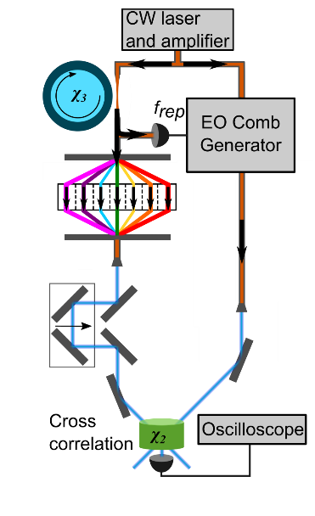

Fig. S1. Schematic depiction of the set-up for using an electro-optic (EO) modulator comb as a reference pulse to measure the time-domain waveform of the crystal. The $χ_{3}$ (Kerr) and $χ_{2}$ nonlinearities are indicated on the resonator and nonlinear crystal, respectively. A spatial-light modulator is used to rotate the phase of the pump laser by $π$ in the crystal to improve the cross-correlation contrast. The soliton crystal and the EO modulator comb share a pump laser, and the repetition frequency $f_{rep}$ of the EO modulator comb is locked to that of the crystal. Varying the relative delay in one arm of the interferometer allows a measurement of the intensity cross-correlation between the crystal and the reference pulse.

**Phase steps:** Soliton crystals exhibit phase steps previously reported by Del’Haye et al.7 We plot simulations of several crystals with spectral phase in Figure S2. We note that, because a linear spectral phase shift is equivalent to a shift in time, there are infinitely many ways to present the spectral phase for a given crystal, and they may not appear obviously equivalent. The phase steps exhibited by soliton crystals arise due to the superposed linear spectral phase shifts from temporally-separated co-propagating solitons.

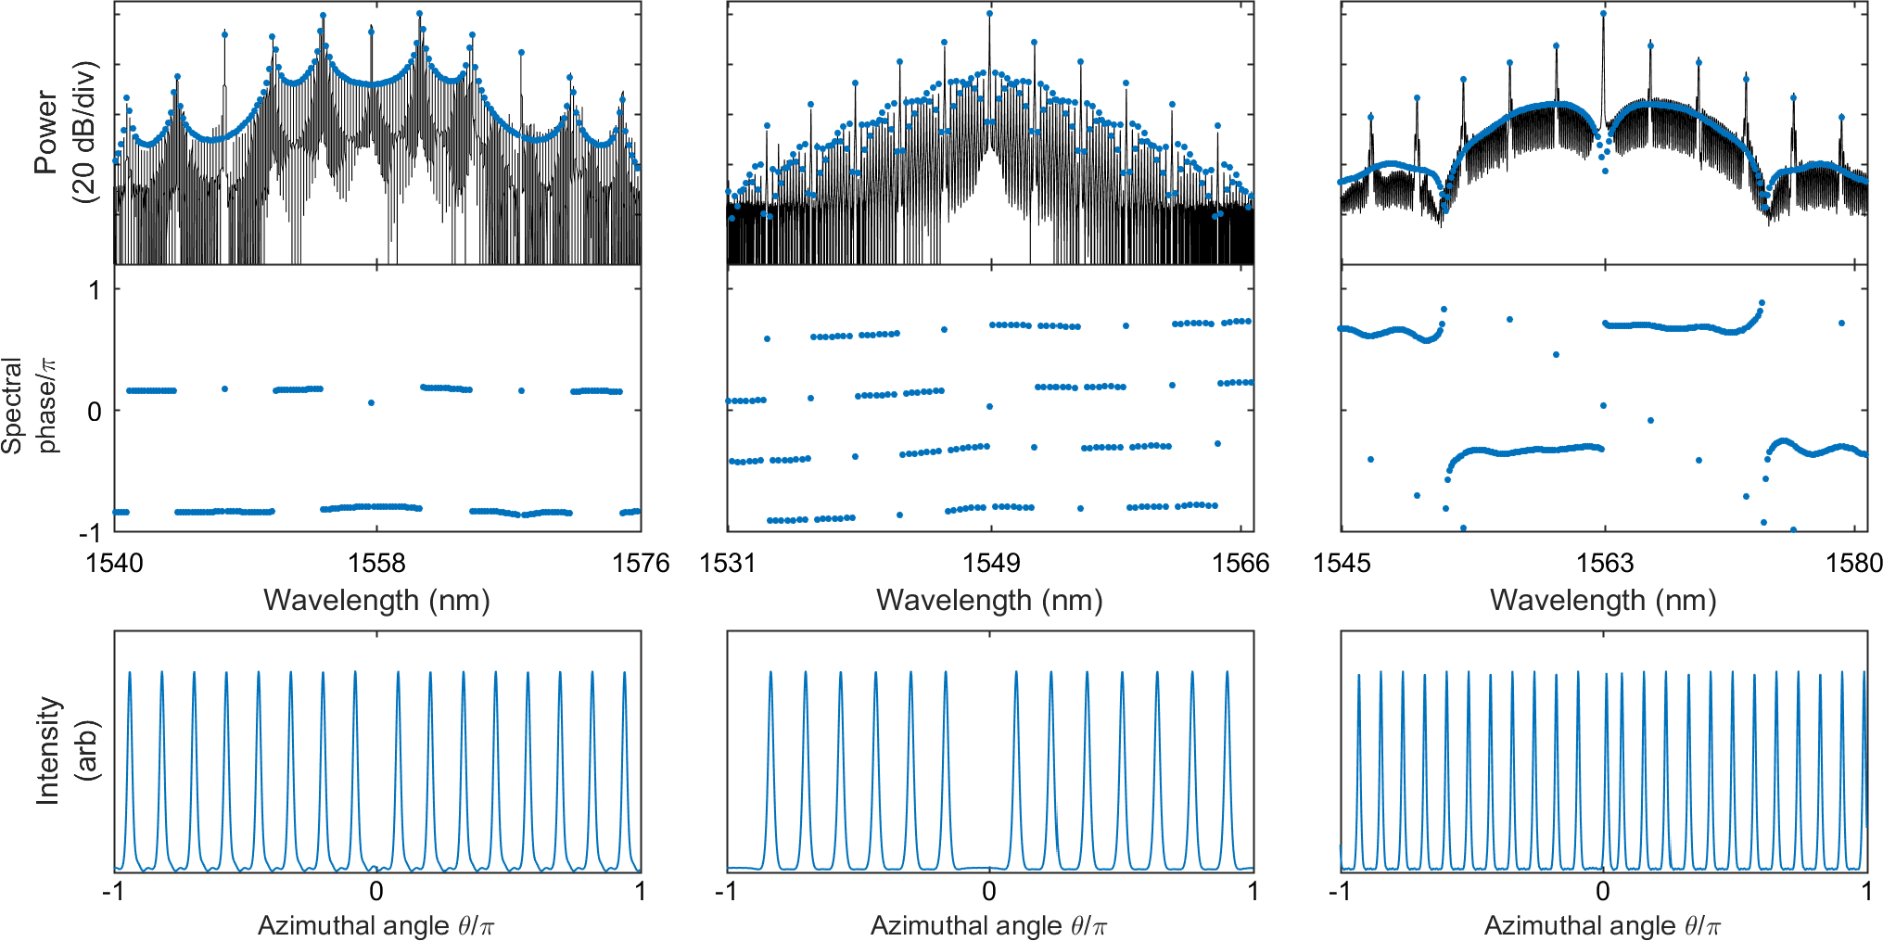

Fig S2. Depiction of crystals (p), (d), and (g) from Fig. 3 of the main text, with experimental data in black and simulations in blue, including simulated spectral phase. These crystals exhibit phase steps near prominent features of the spectrum, which arise due to the spectral interference between temporally-shifted solitons. Spectral phase is unique only up to a shift linear in frequency, which can yield multiple phase profiles for the same crystal which appear very different.

**Harmonic mode-locking:** We have compared and contrasted soliton ensembles in the tightly-packed and sparsely-populated regimes in the main text. In conducting numerical simulations, we have also observed harmonic mode-locking in Kerr combs. Harmonic mode-locking consists of the generation of a uniform soliton train, and occurs in a density regime between the low-density and high-density regimes discussed in the text. In simulations, soliton ensembles in an intermediate-density regime which are initialized with non-uniform soliton distributions will evolve to uniformity, with a spectrum resembling primary comb. Harmonic mode-locking does not require the presence of a mode crossing, and the harmonic mode-locking we have observed involves only the evolution towards a uniform pulse train; no other crystal structure has been discovered. Harmonic mode-locking is a weak effect: the timescale over which a non-uniform pulse distribution will evolve to uniformity in the case of harmonic mode-locking is on the scale of 103–105 photon lifetimes, compared with <10 photon lifetimes for crystallization of a non-uniform pulse train under the influence of a mode crossing. In Figure S3 we present simulations of harmonic mode-locking beginning from a uniform pulse train with jittered pulse positions, and beginning from a uniform pulse train with a vacancy. The numbers of solitons in these harmonically mode-locked states are 15 and 14, respectively; the simulation is conducted under the same conditions in which we have experimentally observed crystallization with 23 pulses in the presence of a mode crossing.

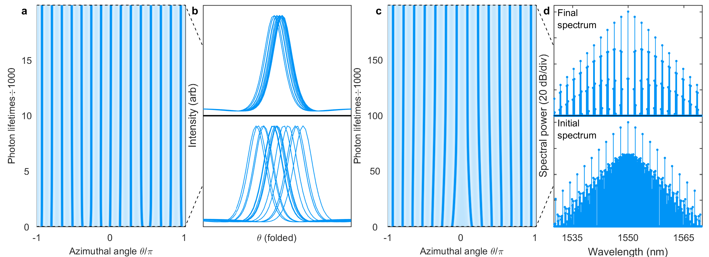

Fig S3. Simulations of harmonic mode-locking, or the evolution towards a uniform soliton train without the presence of a mode crossing. (a-b) Harmonic mode-locking of 15 pulses beginning from jittered, non-uniform pulse positions. Initial and final pulse configurations are shown in (b) with the angular coordinate folded modulo $2π/15$ to illustrate the degree of regularity of the pulse distribution. The pulse distribution evolves towards a uniform pulse train, but approaches that distribution slowly. (c-d) Harmonic mode-locking of 14 pulses beginning from a uniform 15-soliton pulse train with a single vacancy. Initial and final spectra shown in (d).

**Instability of soliton crystals under the LLE:** As discussed in the text, the soliton crystals we have observed cannot be modelled by the LLE alone. The spectral bandwidth fixes the width of the pulse in the time-domain (because pulse chirp is uniquely determined by the LLE), and during propagation under the LLE soliton crystals exhibit inter-pulse attractive interactions and pair annihilation. Fig. S4 presents an example of the propagation of a crystal under the LLE.

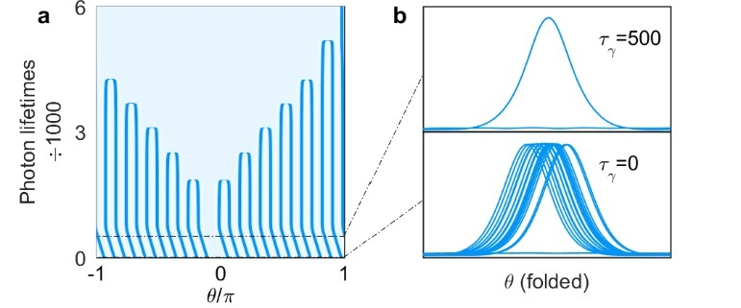

Fig. S4. Intability of soliton crystals under the LLE. (a) Simulated evolution of the pulse train corresponding to the experimental crystal spectrum shown in Fig. 1, starting from irregular pulse positions. Crystallization occurs within 10 photon lifetimes of the initialization of the simulation. For the first 500 photon lifetimes of the simulation, the propagation is governed by a perturbed LLE including reduced comb-resonator detuning on modes 5 x 24=120 and 7 x 24=168. During this time the crystal drifts within the co-rotating frame because the optical spectrum is asymmetric. The perturbation is then removed smoothly from 500 to 1000 photon lifetimes and subsequently the pulses pair-annihilate, demonstrating that the mode crossing is critical for stabilizing the soliton crystal. (b) Intracavity power with the angular coordinate folded modulo $2π/24$, to depict the irregularity of the pulse positions at the initialization of the simulation and the crystallized pulse train after 500 photon lifetimes.

References

1. Chembo, Y. K. & Menyuk, C. R. Spatiotemporal Lugiato-Lefever formalism for Kerr-comb generation in whispering-gallery-mode resonators. *Phys. Rev. A* **87,** 053852 (2013).

2. Godey, C., Balakireva, I. V., Coillet, A. & Chembo, Y. K. Stability analysis of the spatiotemporal Lugiato-Lefever model for Kerr optical frequency combs in the anomalous and normal dispersion regimes. *Phys. Rev. A* **89,** 063814 (2014).

3. Coen, S., Randle, H. G., Sylvestre, T. & Erkintalo, M. Modeling of octave-spanning Kerr frequency combs using a generalized mean-field Lugiato-Lefever model. *Opt. Lett.* **38,** 37–39 (2013).

4. Sinkin, O. V., Holzlöhner, R., Zweck, J. & Menyuk, C. R. Optimization of the split-step Fourier method in modeling optical-fiber communications systems. *J. Light. Technol.* **21,** 61–68 (2003).

5. Hult, J. A Fourth-Order Runge-Kutta in the Interaction Picture Method for Simulating Supercontinuum Generation in Optical Fibers. *J. Light. Technol.* **25,** 3770–3775 (2007).

6. Chembo, Y. K. & Yu, N. Modal expansion approach to optical-frequency-comb generation with monolithic whispering-gallery-mode resonators. *Phys. Rev. A* **82,** 033801 (2010).

7. Del’Haye, P. *et al.* Phase steps and resonator detuning measurements in microresonator frequency combs. *Nat. Commun.* **6,** 5668 (2015).